Navigation

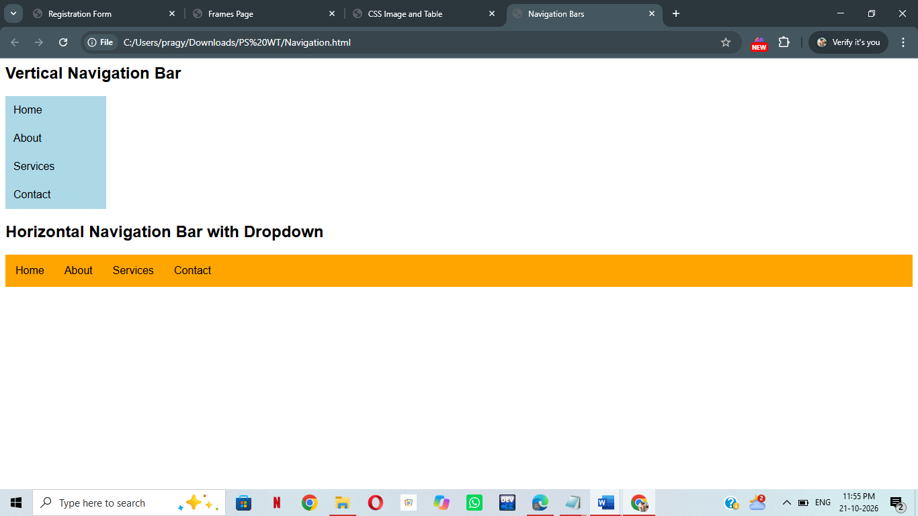

<html>
<head>
<title>Navigation Bars</title>
<style>
body{font-family:Arial;}
ul{list-style-type:none;margin:0;padding:0;}
.vertical{width:150px;}
.vertical li a{display:block;padding:12px;background-color:lightblue;color:black;text-decoration:none;}
.vertical li a:hover{background-color:pink;}
.horizontal{display:flex;background-color:orange;}
.horizontal li{position:relative;}
.horizontal li a{display:block;padding:15px;color:black;text-decoration:none;}
.horizontal li a:hover{background-color:skyblue;}
.dropdown{display:none;position:absolute;top:100%;left:0;background-color:white;min-width:150px;padding:0;}
.dropdown li a{padding:10px;}
.horizontal li:hover .dropdown{display:block;}
</style>
</head>
<body>
<h2>Vertical Navigation Bar</h2>
<ul class="vertical">
<li><a href="home.html">Home</a></li>
<li><a href="abount.html">About</a></li>
<li><a href="services.html">Services</a></li>
<li><a href="contact.html">Contact</a></li>
</ul>
<h2>Horizontal Navigation Bar with Dropdown</h2>
<ul class="horizontal">
<li><a href="home.html">Home</a></li>
<li><a href="about.html">About</a></li>
<li><a href="services.html">Services</a>
<ul class="dropdown">
<li><a href="web design.html">Web Design</a></li>
<li><a href="development.html">Development</a></li>
<li><a href="seo.html">SEO</a></li>
</ul>
</li>
<li><a href="contact.html">Contact</a></li>
</ul>
</body>
</html>

